MySQL Assignment 1 – DDL Commands & Constraints
Employee Database schema:
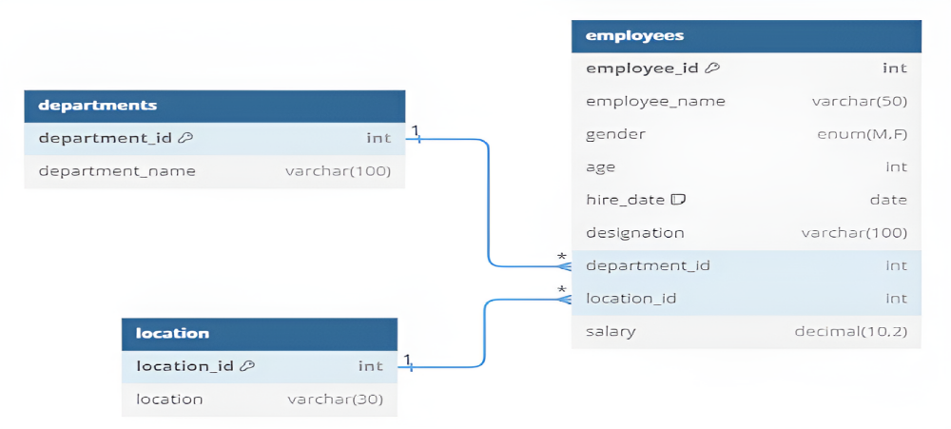
DDL Commands :
1. Table Creation (CREATE): Write the SQL statements to create a database named “employee” and the following tables based on the provided schema:
⦿ Departments
⦿ Location
⦿ Employees
2. Table Alteration (ALTER): Consider the following scenarios and write the SQL statements to alter the structure of the tables accordingly:
⦿ Add a new column named "email" to the Employees table to store employee email addresses.
⦿ Modify the data type of the "designation" column in the Employees table to support a wider range of values.
⦿ Drop the “age” column from the Employees table.
⦿ Rename the “hire_date” column to “date_of_joining”.
3. Table Renaming (RENAME): Rewrite the SQL statements to rename the following tables:
⦿ Rename the "Departments" table to "Departments_Info".
⦿ Rename the "Location" table to "Locations".
4. Table Truncation (TRUNCATE): Write an SQL statement to truncate the Employees table.
5. Database & Table Dropping (DROP): Write the SQL statements to drop the Employees table and then the “employee” database.
Constraints :
1. Database Recreation:
⦿ Drop the 'employee' database if it exists and recreate it using the provided schema, ensuring that all tables are created with the appropriate constraints as instructed.
2. Departments Table:
⦿ Ensure that the "department_id" uniquely identifies each department.
⦿ Set up constraints on the "department_name" to avoid duplicate and null entries.
3. Location Table:
⦿ Establish a mechanism to automatically generate unique identifiers for each location, ensuring that they are incremented sequentially.
⦿ Implement constraints to prevent the insertion of null and duplicate locations.
4. Employees Table:
⦿ Guarantee that each employee has a distinct identifier.
⦿ Create a restriction to ensure that the employee's name is always provided.
⦿ Limit the acceptable values for the "gender" field to only 'M' or 'F'.
⦿ Enforce a condition to ensure that the employee's age is 18 or above.
⦿ Automatically assign the current date to the "hire_date" field if not specified.
⦿ Establish links between the "department_id" and "location_id" fields in the "employees" table and their respective tables.
MySQL Assignment 1 – DDL Commands
Answers
- CREATE TABLE departments(
department_id int NOT NULL PRIMARY KEY,
Department_name varchar(100)
);

CREATE TABLE Location(
location_id int NOT NULL PRIMARY KEY,
Location varchar(30)
);

CREATE TABLE Employees(
employee_id int NOT NULL PRIMARY KEY,
Employee_name varchar(50),
Gender enum(‘M’,’F’),
Age int,
Hire_date date,
Designation varchar(100),
Department_id int,
Location_id int,
Salary decimal(10,2) ,

FOREIGN KEY Department_id
REFERENCES departments(department_id),

FOREIGN KEY Location_id
REFERENCES Location(location_id)
);

2.
  - ALTER TABLE Employees
ADD COLUMN Email varchar(80);
- ALTER TABLE Employees
MODIFY COLUMN Designation varchar(150);
- ALTER TABLE Employees
DROP COLUMN Age;
- ALTER TABLE Employees
RENAME COLUMN hire_date TO date_of_joining;

- RENAME TABLE Departments TO Departments_Info;
- RENAME TABLE Location TO Locations;

    - TRUNCATE TABLE Employees;
    - DROP TABLE Employees;
DROP DATABASE IF EXISTS Employee;

Constraints:-
- DROP DATABASE IF EXISTS Employee;
CREATE DATABASE IF NOT EXIXTS Employee;
USE Employee;
- CREATE TABLE Departments(
Department_id int NOT NULL PRIMARY KEY,
Department_name varchar(100) NOT NULL UNIQUE
);

- CREATE TABLE Location(
Location_id int AUTO_INCREMENT NOT NULL PRIMARY KEY,
Location varchar(30) NOT NULL UNIQUE
);

- CREATE TABLE Employees(
employee_id int NOT NULL PRIMARY KEY,
Employee_name varchar(50) NOT NULL,
Gender enum(‘M’,’F’),
Age int CHECK (Age>=18),
Hire_date date DEFAULT CURRENT_DATE,
Designation varchar(100),
Department_id int,
Location_id int,
Salary decimal(10,2) ,

FOREIGN KEY Department_id
REFERENCES departments(department_id),

FOREIGN KEY Location_id
REFERENCES Location(location_id)
);

